Accommodation within walking distance to

Marino Institute of Education

Applewood B&B

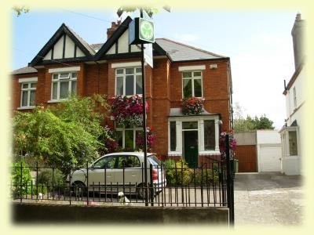144 Upper Drumcondra Road
Dublin 9
Tel: 00353 1 837 83 28
http://www.applewood.ie/

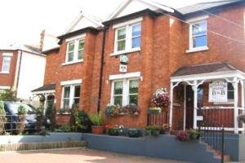

Willow house B&B

130 Upper Drumcondra Road
Dublin 9
Tel: 00353 1 837 57

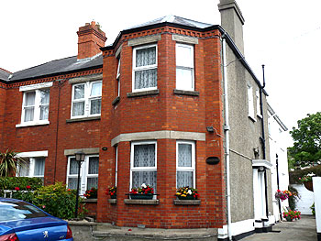

Baldara House

126 Upper Drumcondra Road
Dublin 9
Tel: 00353 1 836 86 68
http://dirl.com/dublin/drumcondra/baldara-house.htm

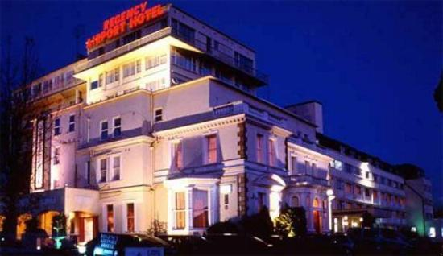
Bonnington Hotel

Swords Road Drumcondra Dublin 9
Tel: 00353 1 837 15 31
https://www.bonningtondublin.com/

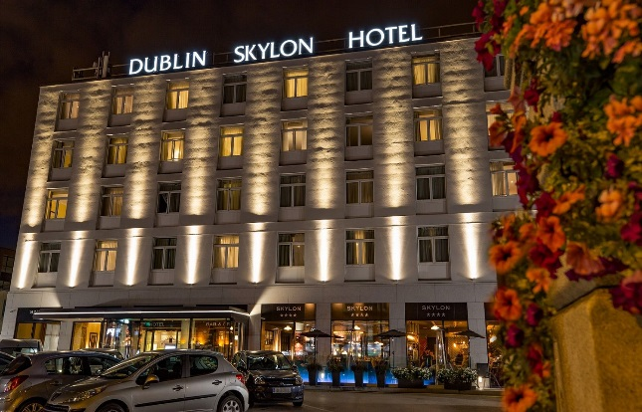

Skylon Hotel

Upper Drumcondra Road
Dublin 9
Tel: 00353 1 884 39 00
https://www.dublinskylonhotel.com/

