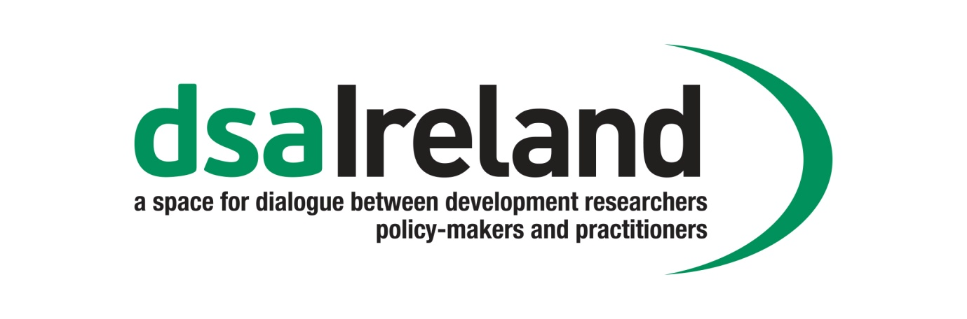

**Strategic Plan 2017 – 2019**

**Context**

Ireland has a long history of commitment to international development through research, informing policy and working with vulnerable and disadvantaged communities around the world. Key to moving towards a more just and equal world, based on respect for human rights, is the use of research in a coherent and effective manner to inform and develop policy and practice, which has a real impact on improving the lives of the most vulnerable.

Development studies in Ireland is an active, but sometimes fragmented community, spread across colleges, universities, NGOs and voluntary organisations, often with little or no opportunity to connect with those working in similar areas. DSA Ireland (DSAI) fills this gap, by providing a platform to bring together researchers, policy-makers and practitioners, to share research findings and to facilitate evidence-based policy and practice.

**Foundation**

Following the 2009 DSA UK and Ireland Conference at the University of Ulster, Coleraine, a group of Irish based members came together to create a focus for development studies in Ireland. This loose network operated as a Study Group of DSA UK and Ireland and thus obtained a subsidy for annual conferences in 2010 (TCD), 2011 (NUIM) and 2012 (DCU) as well as postgraduate training events in 2011 (UL) and 2012 (UCC). A subsidy was also provided in terms of support staff by TIDI (the Trinity International Development Initiative), Trinity College Dublin, and the office of Civic and Global Engagement, Dublin City University.

The network held a strategy session in 2011 and decided to formalise its structures and seek Irish Aid support for its consolidation. Minister of State at the Department of Foreign Affairs and Trade, Joe Costello, announced support from the Department of Foreign Affairs for the formation of Development Studies Association Ireland at the 2012 annual conference, which also saw the election of a Steering Committee with office holders and the foundation of DSA Ireland as an independent national association representing development studies in Ireland. The appointment of a half time coordinator in 2013 completed the process of formalisation, underpinned by institutional commitments by Trinity College Dublin and Dublin City University.

A clear aim of DSA Ireland is to consolidate and expand its remit to act as a forum for Irish development studies, in which to further enhance the research capacity and capabilities of the sector. DSA Ireland plans to further develop its capacities and work programmes, based on individual and institutional membership. It has established a broad system of alliances across the development sector, and a set of key strategic public events, including an annual conference, policy workshops, research training sessions and study group seminars. These meet the needs of its members and provide a space for research dissemination and high quality debate on the key issues in development studies and practice.

**Our Vision**

The **vision** of DSA Ireland is the creation of a vibrant and innovative development studies community, which focuses on cutting edge research, led by research institutions across the island of Ireland, contributing to the reduction of poverty, inequality and vulnerability in the world.

**Our Mission**

The mission of DSA Ireland is to provide a national platform, which provides an open and participatory space for dialogue between researchers, policy-makers and practitioners, who have an interest in, or are working in the area of international development. We achieve this by:

* supporting cohesion and capacity-building in the development studies sector;
* promoting strategic alliances and partnerships to grow the development studies sector;
* harnessing research which supports and promotes coherent evidence- based development policy and practice aimed at the reduction of global poverty, the enhancement of all forms of equality and respect for human rights.

**Our Values**

DSA Ireland’s **values** are:

* The focus of development research on the overarching goal of human betterment and poverty reduction;
* Development research as Southern driven, particularly in terms of setting the research agenda;
* Development research to encourage the empowerment of women in setting and implementing the development agenda;
* Development research that respects individuals and communities;
* Development research that seeks to be as participatory as possible and is wary of unduly raising expectations;
* Development research that seeks to be as reflexive and self- critical as possible, bearing in mind the importance of positionality;
* Development research to work through partnerships with communities and agencies while fully respecting their independence and the integrity of the research;
* Development research that guards against anything that may cause harm to participants and makes sure their rights in regards to data and confidentiality are respected;
* Development research that is geared towards the practical needs of social transformation, providing clear and accessible guides to action;
* Development research that continuously endeavours to adhere to clear ethical guidelines on the conduct of research.

**Our Key Objectives**

In order to achieve our **mission** we will focus on the following **key objectives**:

* promote a meaningful platform for sustained dialogue across the development studies ‘constituency’.
* generate critical debate and rich, well informed perspectives on development issues;
* promote high-quality interdisciplinary and ethical research on development-related issues among research partners in Ireland (specifically HEIs and NGOs),
* stimulate researchers to work collaboratively to gather, create and share knowledge in these spaces;
* identify critical gaps in the knowledge of development and challenges;
* inform national policy on development through linking research, policy and practice.

**DSA Ireland’s Governance**

DSA Ireland is a membership based and membership driven organisation. It is an independent all Ireland Association enjoying reciprocal membership rights with the DSA (UK). In 2017, DSAI also became a representative on the board of the European Association of Development Institutes (EADI).

The Annual General Meeting of DSA Ireland is the sovereign body of the Association and its agreement is required for any substantial change in mission and strategy. It elects the Steering Committee, comprising up to 10 members, who in turn elect the officers of the Association, namely a Chair, Secretary and Treasurer for a term of two years. These officers can be re-elected for an additional 2-year term, with the exception of the Chair who will only serve for one 2-year term. The Steering Committee can co-opt two further members as required to meet the work commitments of the Association.

DSAI governance is open to all members. Members should feel they can participate in steering the network and the governance of the Association will evolve as members require. All minutes of meetings are published on the member’s area of the DSA Ireland website, as are the budget and annual financial statement of the organisation. DSAI accounts are held at Trinity College Dublin and Dublin City University and are audited therein. The DSA Ireland Treasurer, with the Secretary and the Chair, is responsible for preparing an annual budget, which is approved by the Steering Committee.

The management of DSA Ireland rests with the Steering Committee, which meets on a bi-monthly basis. Its work is, at all times, guided by the strategy of the Association. All members of the Steering Committee carry responsibility for specific briefs or portfolios contributing to the overall strategic development of DSA Ireland and to delivering on its commitments. The DSAI Steering Committee actively welcomes engagement by the membership and all ideas and initiatives that contribute to advancing the vision, mission and objectives of the Association.

In between Steering Committee meetings, day-to-day management rests with a Secretariat comprising of the DSA Ireland Officers (Chair, Secretary and Treasurer) and the Coordinator. If urgent decisions are required an electronic poll of the Steering Committee will be carried out.

DSA Ireland is comprised of Study Groups, which grow organically within the Association, based on the interest of members. Study Groups are open to all DSA Ireland members and are opportunities for members to link with those who have an interest in the same research area in international development. There is also a Postgraduate Researchers Working Group, which promotes post-graduate members interests in the activities of DSA Ireland, and furthers opportunities for learning, dissemination and network building. Postgraduate students are a key constituency in the growth of DSA Ireland.

**Our Key Priorities for 2017 – 2019**

In order to further develop our remit, we focus on the following **key priorities**:

* Design and develop a portfolio of activities focused on particular target audiences. In particular:
* Establish the Annual Conference as a leading international event for academics and practitioners in development work.
* Develop the relevance and quality of the Summer School.
* Organise themed seminars and workshops annually.
* Promote research and education on thematic priorities aligned with the Irish Aid strategy, particularly through the work of the Study Groups.
* Support, develop and promote focused Study Groups with defined yet diverse plans of activity
* Support the work and aspirations of young and early career researchers through the association, including our Postgraduate Network.
* Publish Study Group and member working papers and policy briefs.
* Grow and support an active individual and institutional membership base
* Develop international networks with other development associations and research institutes

**Workplan 2017**